“How Nepal’s fielding identity has quietly become its potent weapon”

In 2025, Nepal qualified for yet another T20 World Cups, their consecutive world cup qualification after having qualified for the tournament in 2021/22. In the build up to the qualification, and the matches Nepal played in 2025, it seemed like they were finading a knack to take key wickets through run-outs.
This observation led me to look at the data for all the T20 matches Nepal played in 2025, and the data seemed to agree with the observation.

From the 17 matches, 16 of which were completed, Nepal have played in 2025 (as of 29th November, 2025), caught accounts for 52.3%, and run outs account for 12.5% of the dismissals. They’ve affected 16 run outs in 11 matches, and average a run out a match.
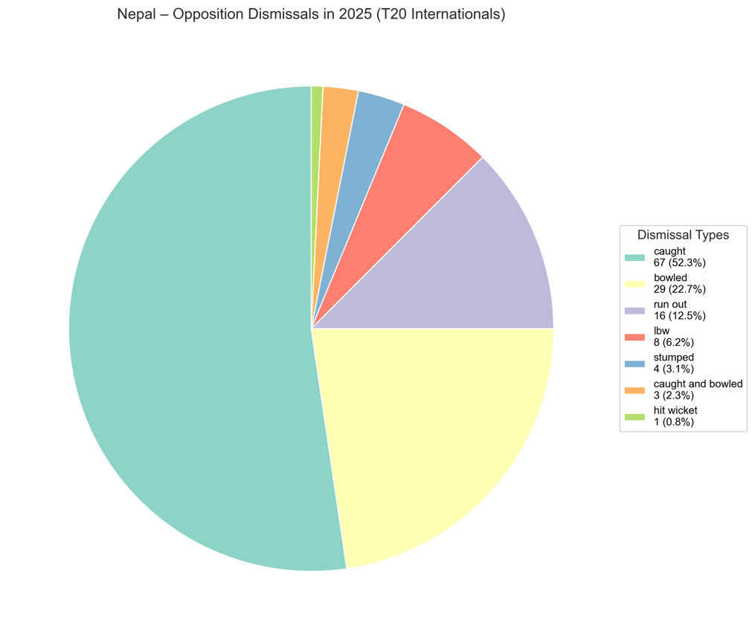
During the world cup qualfiers in crunch moments Nepal were able to get wickets through run outs, thus helping their cause to qualify. In the cruch game against UAE, they were able to affect 3 run-outs, helping edge out the match by a single run.
Astonishingly, Nepal has been able to affect a high percentage of direct hits, which often are close calls.
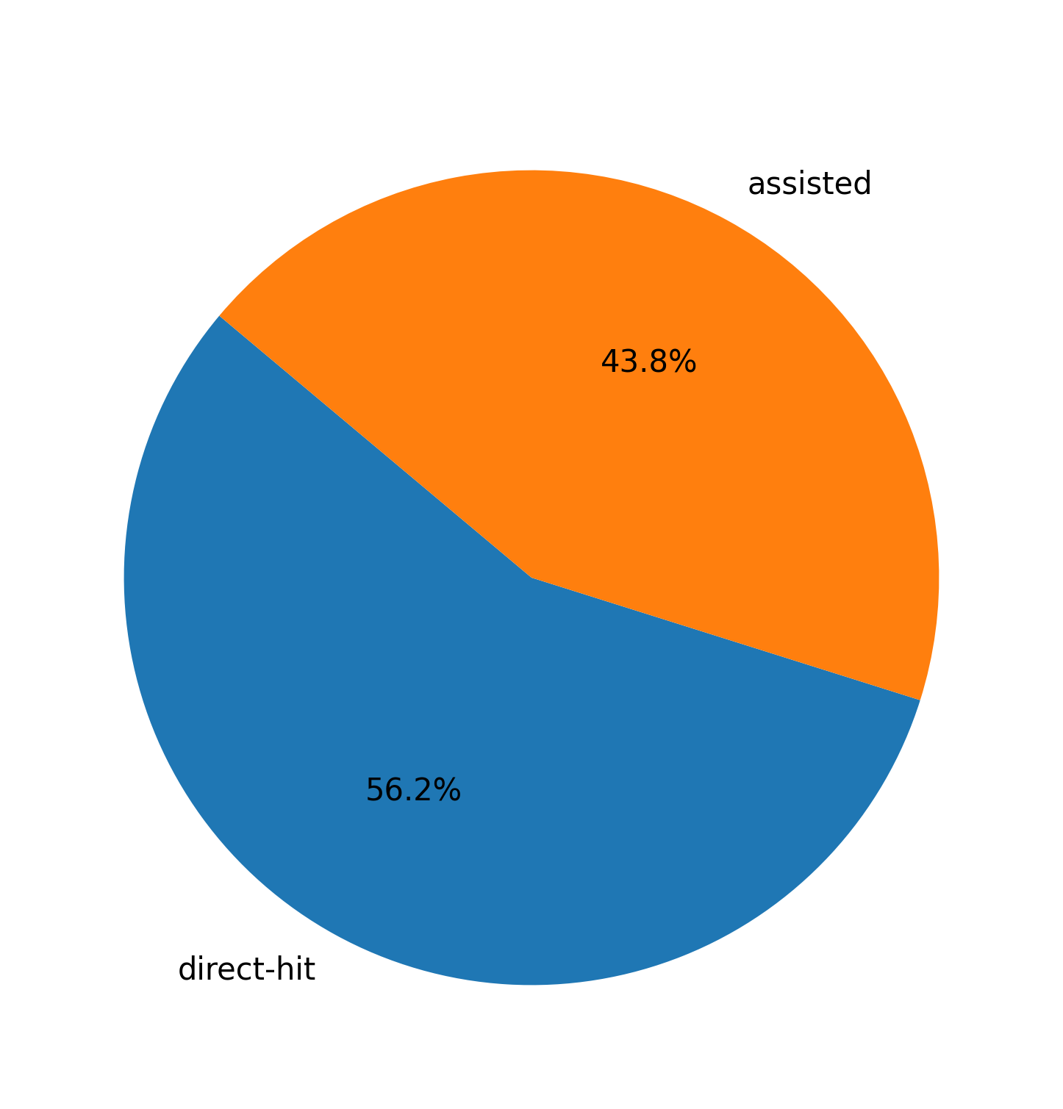
56% of Nepal’s run out dismissals came through direct hits, of which Dipendra Singh Airee had 5 direct hits to his name.
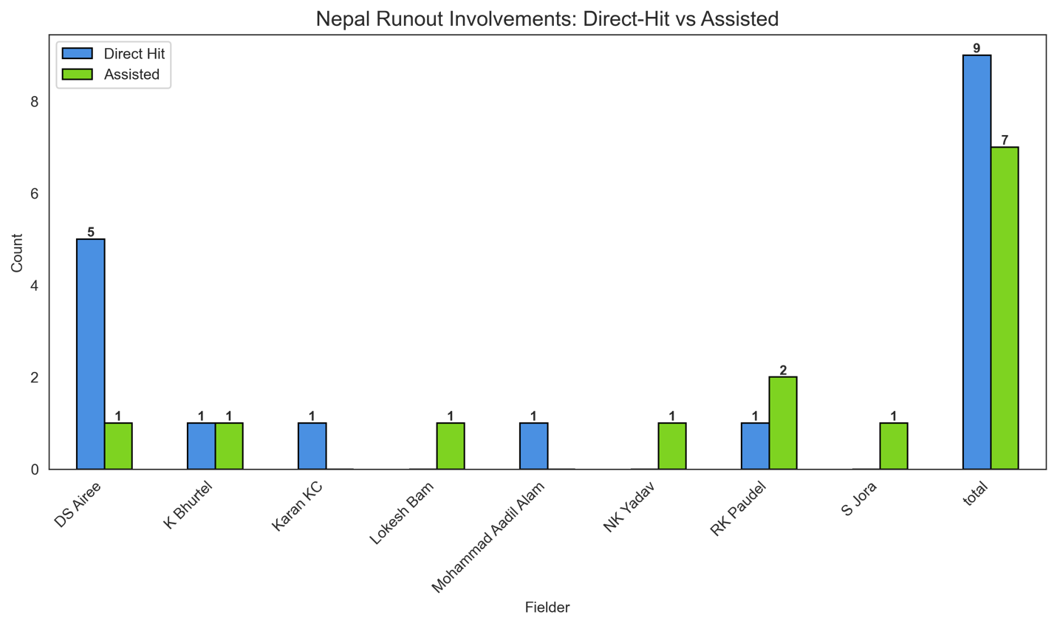
Most run-outs victims have been the middle order batsmen (4-8), and it goes to show, Nepali fielders become that extra bowler in the middle over, taking crucial wickets. There are also a few run-out victims at the top of the order, and only one victim is a lower-order batsman.
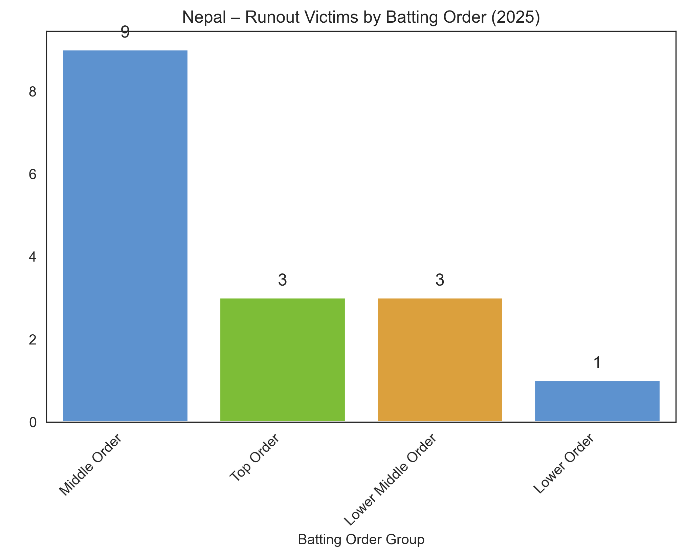

As “Catches win you Matches”, the rules seem to definitely apply claiming “Run out” dismissal. Nepal have been win 10 of the 11 games they’ve inflicted run outs, their only loss coming to Kuwait.
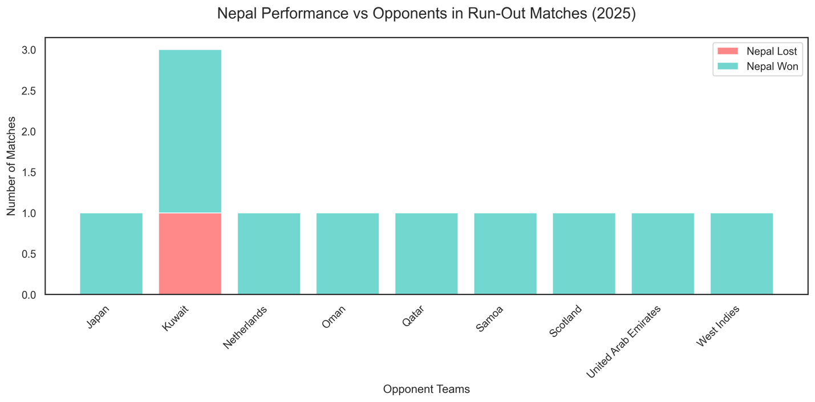
The cardiac kids, as they’ve been appropriately named, for playing some nerve wrecking matches, do seem to have a potent weapon in them especially with their fielding, and their ability to inflict run outs.
It will be interesting to see if the likes of England, Bangladesh, West Indies and _______, take heed of this and avoid taking risky singles because the Nepali fielders are on their feet.

Better structure (same content, different order):
- Start with the UAE game anecdote (hook)
- “Is this a pattern?” → Introduce the 2025 dataset
- The headline stat (16 run outs, 56% direct hits)
- Individual standouts (DS Airee)
- Batting-order vulnerability
- Win correlation
- Why this matters vs bigger teams
- Closing “identity” paragraph

